**SENTIMENT ANALYSIS FOR MARKETING**

**BATCH MEMBER**

**815621104033: Sathish Kumar.R**

**Phase-4 submission document**

**Project Title**: Sentiment Analysis for Marketing

**Phase 4:** Development Part 2

**Topic:** Continue building the sentiment analysis solution by Employing NLP techniques and Generating insights.

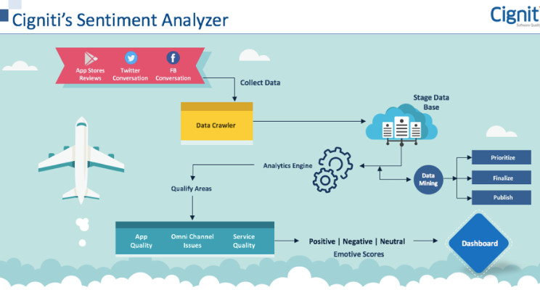

Sentiment Analysis for Marketing

**Introduction:**

* In the intricate domain of marketing, understanding customer sentiment is pivotal for businesses to adapt and thrive. A sentiment analysis solution holds the potential to discern the underlying emotions behind consumer responses, reviews, and feedback. This extensive guide will navigate through the development of a potent sentiment analysis solution by employing two vital areas: Natural Language Processing (NLP) techniques and the generation of actionable insights.
* Natural Language Processing (NLP) is a sub-field of artificial intelligence that focuses on the interaction between computers and humans through natural language. Leveraging NLP for sentiment analysis allows businesses to automatically parse, analyze, and interpret vast amounts of textual data, extracting sentiments and emotions expressed by consumers.
* Generating insights from the analyzed sentiments is the next step, which translates raw sentiment data into actionable strategies, guiding marketers to make informed decisions. These insights shed light on product reception, brand reputation, and areas of potential growth or concern.

**Given data set:**

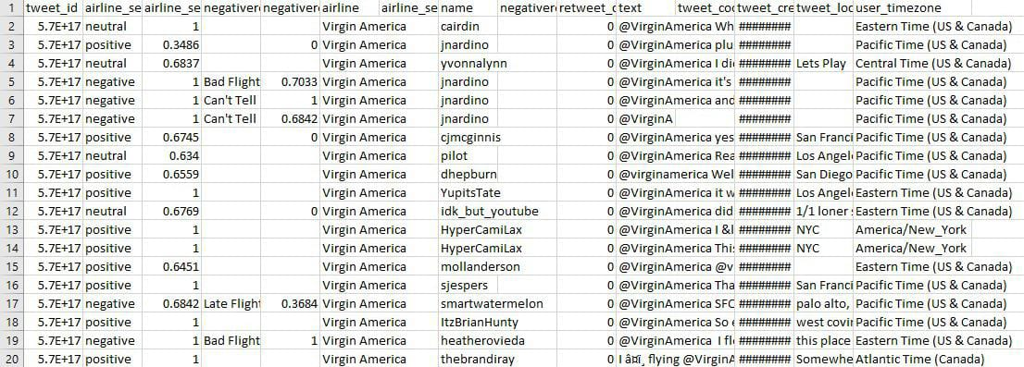

**Overview of the process:**

Outlined below is a comprehensive walkthrough for constructing a sentiment analysis solution employing NLP techniques and generating insights:

1. **Data Collection:** Gather textual data from diverse sources like reviews, social media, feedback forms, and customer interactions.
2. **Data Preprocessing:** Implement text cleaning processes to remove noise, such as punctuation, special characters, and numbers. Normalize the text through stemming and lemmatization.
3. **Employ NLP Techniques:** Use tokenization to split text into words or sentences. Implement algorithms to classify the sentiments into categories like positive, negative, and neutral.
4. **Feature Engineering:** Develop features that can boost the model's prediction accuracy, such as the frequency of sentiment words, sentence structures, or context embeddings.
5. **Model Training:** Feed the processed data to machine learning algorithms, allowing them to learn and understand the sentiment patterns.
6. **Generating Insights:** Interpret the sentiment analysis results to derive actionable marketing strategies. This could involve understanding product reception, customer pain points, or market trends.
7. **Model Evaluation:** Use metrics such as accuracy, precision, recall, and F1-score to gauge the performance of the sentiment analysis model on unseen data.
8. **Deployment:** After satisfactory evaluation, the model can be integrated into marketing tools or platforms to provide real-time sentiment analysis and insights.

**PROCEDURE:**

**Employing NLP Techniques:**

1. **Tokenization:** Break down the text into smaller pieces, like words or sentences.
2. **POS Tagging:** Identify the part of speech for each token.
3. **Named Entity Recognition:** Detect and classify entities like product names, brands, or user names.
4. **Sentiment Lexicons:** Use pre-existing lexicons that have sentiment scores for words, helping in sentiment determination.
5. **Deep Learning:** Implement techniques like LSTM or BERT for sentiment classification, especially when context matters.

**Employing NLP Techniques:**

In[1]:

text = "I love this product! It's amazing."

sentiment_score = afinn.score(text)

if sentiment_score > 0:

sentiment = "positive"

elif sentiment_score < 0:

sentiment = "negative"

else:

sentiment = "neutral"

print(f"Sentiment: {sentiment}, Score: {sentiment_score}")

In[2]:

*# Identify and print the most positive words*

print('Most Positive Words')

for word, index **in** word_index_map.items():

weight = model.coef_[0][index]

if weight > threshold:

print(word, weight)

Most Positive Words

great 5.516378614880334

virginamerica 3.4165631737297506

thank 8.172492647617368

southwestair 2.728627527382746

jetblue 3.1586422137139065

thanks 8.083441401654769

good 2.805464965619352

love 4.449114200749592

best 3.8620140153411207

appreciate 2.336612511736386

awesome 4.091284298701974

nice 2.16154339981104

thx 2.4222423243948117

amazing 3.6943805117897175

excellent 2.6209683927563843

worries 2.7557781608971568

wonderful 2.240905852132964

kudos 2.87036770762045

In[3]:

*# Vectorize text data using TF-IDF*

vectorizer = TfidfVectorizer(max_features=2000)

x_train = vectorizer.fit_transform(df_train['text'])

x_test = vectorizer.transform(df_test['text'])

y_train = df_train['target']

y_test = df_test['target']

In[4]:

*# Vectorize text data for the binary sentiment classification*

x_train = vectorizer.fit_transform(df_b_train['text'])

x_test = vectorizer.transform(df_b_test['text'])

y_train = df_b_train['target']

y_test = df_b_test['target']

In[5]:

*# Splitting the data into training and testing sets*

from sklearn.model_selection import train_test_split

X_train, X_test, y_train, y_test = train_test_split(df['text'], df['airline_sentiment'], test_size=0.2, random_state=42)

*# Feature Extraction*

from sklearn.feature_extraction.text import TfidfVectorizer

vectorizer = TfidfVectorizer(max_features=2500, min_df=7, max_df=0.8)

X_train = vectorizer.fit_transform(X_train).toarray()

X_test = vectorizer.transform(X_test).toarray()

*# Model Training*

from sklearn.ensemble import RandomForestClassifier

classifier = RandomForestClassifier(n_estimators=1000, random_state=0)

classifier.fit(X_train, y_train)

Out[5]:

RandomForestClassifier

RandomForestClassifier(n_estimators=1000, random_state=0)

In[6]:

*# Count the occurrences of each sentiment category*

sentiment_counts = df['airline_sentiment'].value_counts()

*# Visualize the distribution using a histogram with counts on bars*

plt.figure(figsize=(8, 6))

ax = sns.histplot(df['airline_sentiment'], bins=3, color='skyblue', discrete=True)

plt.xlabel('Sentiment')

plt.ylabel('Count')

plt.title('Distribution of Airline Sentiments')

*# Add counts on top of the bars*

for p **in** ax.patches:

ax.annotate(f'**{**p.get_height()**}**', (p.get_x() + p.get_width() / 2., p.get_height()), ha='center', va='center', fontsize=12, xytext=(0, 10), textcoords='offset points')

plt.xticks()

plt.show()

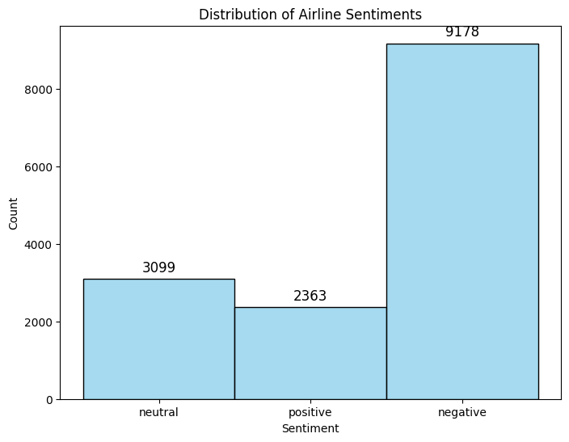

**Generating Insights:**

**1.Sentiment Distribution:** Analyze the overall sentiment spread, understanding if most feedback is positive, negative, or neutral.

**2.Temporal Analysis:** Check sentiment trends over time to identify any changes or anomalies.

**3.Product-specific Insights:** Delve deeper into sentiments about specific products or services, aiding in product improvement or feature addition.

**4.Competitor Analysis:** By analyzing sentiments about competitors, derive strategies to gain a competitive edge.

**5.Target Audience Sentiments:** Understanding the sentiments of different consumer demographics can guide targeted marketing strategies.

In[7]:

*# Function to preprocess the text*

def preprocess_text(text):

*# Remove punctuations and numbers*

text = re.sub('[^a-zA-Z]', ' ', text)

*# Single character removal*

text = re.sub(r'\s+[a-zA-Z]\s+', ' ', text)

*# Removing multiple spaces*

text = re.sub(r'\s+', ' ', text)

*# Converting to Lowercase*

text = text.lower()

*# Lemmatization*

*#text = text.split()*

*#lemmatizer = WordNetLemmatizer()*

*#text = [lemmatizer.lemmatize(word) for word in text if not word in set(stopwords.words('english'))]*

*#text = ' '.join(text)*

return text

*# Apply the preprocessing to the 'text' column*

df['text'] = df['text'].apply(preprocess_text)

*# Display the first 5 rows of the dataframe after preprocessing*

df.head()

Out[7]:

|  |  |  |
| --- | --- | --- |
|  | airline_sentiment | text |
| 0 | neutral | virginamerica what dhepburn said |
| 1 | positive | virginamerica plus you ve added commercials t... |
| 2 | neutral | virginamerica didn today must mean need to ta... |
| 3 | negative | virginamerica it really aggressive to blast o... |
| 4 | negative | virginamerica and it a really big bad thing a... |

In[8]:

from sklearn.metrics import classification_report, confusion_matrix, accuracy_score

def evaluate_model(y_test, y_pred):

print('Classification Report:')

print(classification_report(y_test, y_pred))

print('Confusion Matrix:')

print(confusion_matrix(y_test, y_pred))

print('Accuracy Score:')

print(accuracy_score(y_test, y_pred))

y_pred = classifier.predict(X_test)

evaluate_model(y_test, y_pred)

Classification Report:

precision recall f1-score support

negative 0.79 0.95 0.86 1889

neutral 0.65 0.41 0.50 580

positive 0.80 0.50 0.62 459

accuracy 0.77 2928

macro avg 0.75 0.62 0.66 2928

weighted avg 0.76 0.77 0.75 2928

Confusion Matrix:

[[1799 65 25]

[ 312 235 33]

[ 169 60 230]]

Accuracy Score:

0.773224043715847

In[9]:

import matplotlib.pyplot as plt

import seaborn as sns

def plot_confusion_matrix(y_test, y_pred):

cm = confusion_matrix(y_test, y_pred)

df_cm = pd.DataFrame(cm, index = [i for i **in** ['negative', 'neutral', 'positive']],

columns = [i for i **in** ['negative', 'neutral', 'positive']])

plt.figure(figsize = (10,7))

sns.heatmap(df_cm, annot=True, fmt='d', cmap='Blues')

plt.title('Confusion Matrix')

plt.xlabel('Predicted')

plt.ylabel('True')

plt.show()

plot_confusion_matrix(y_test, y_pred)

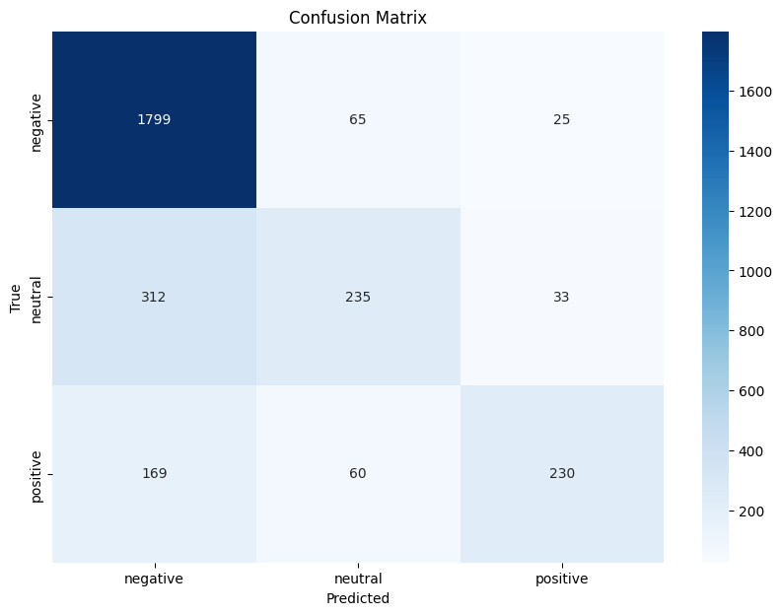

In[10]:

*# Train a logistic regression model*

model = LogisticRegression(max_iter=500)

model.fit(x_train, y_train)

Out[10]:

LogisticRegression

LogisticRegression(max_iter=500)

**Model Evaluation:**

**1.Accuracy:** Measure the fraction of predictions the model got right.

**2.Precision & Recall:** Gauge the model's ability to minimize false positives and false negatives.

**3.F1-score:** A balance between precision and recall.

**4.Confusion Matrix:** A summary of prediction results on a classification problem, highlighting false positives, false negatives, true positives, and true negatives.

In[11]:

*# Visualize the distribution of airline sentiments using a pie chart*

sentiment_counts = df['airline_sentiment'].value_counts()

plt.figure(figsize=(8, 8))

plt.pie(sentiment_counts, labels=sentiment_counts.index, autopct='**%1.1f%%**', startangle=140)

plt.title('Distribution of Airline Sentiments')

plt.axis('equal') *# Equal aspect ratio ensures that pie is drawn as a circle.*

plt.show()

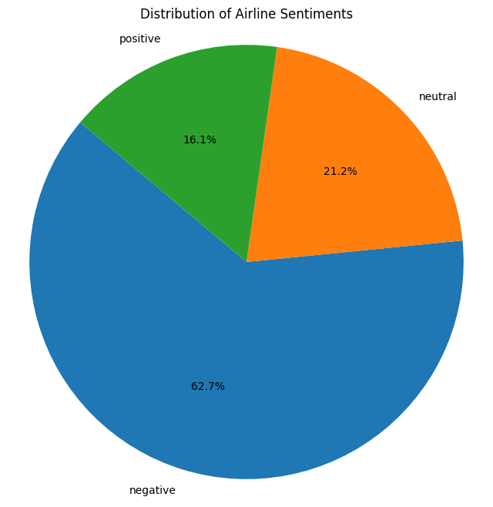

In[12]:

*# Define a threshold for identifying most positive and most negative words*

threshold = 2

In[13]:

*# Plot a histogram of feature weights (coefficients)*

plt.hist(model.coef_[0], bins=40)

plt.xlabel('Feature Weight')

plt.ylabel('Frequency')

plt.title('Distribution of Feature Weights')

plt.show()

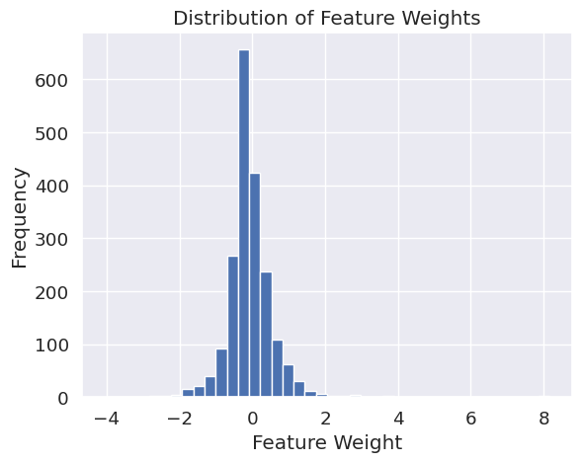

In[14]:

from textblob import TextBlob

text = "I love this product! It's amazing."

blob = TextBlob(text)

sentiment = blob.sentiment

if sentiment.polarity > 0:

sentiment_label = "positive"

elif sentiment.polarity < 0:

sentiment_label = "negative"

else:

sentiment_label = "neutral"

print(f"Sentiment: {sentiment_label}, Polarity: {sentiment.polarity}")

In[15]:

*# Boxplot of tweet lengths*

plt.figure(figsize=(8,6))

sns.boxplot(x='airline_sentiment', y='tweet_length', data=df)

plt.title('Distribution of Tweet Lengths by Sentiment')

plt.show()

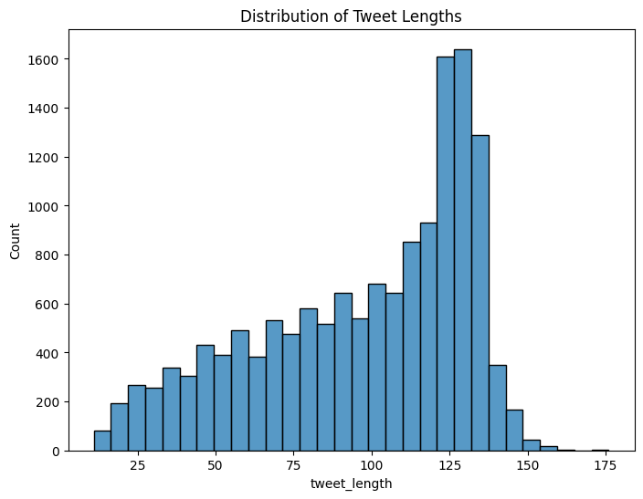

In[16]:

labels = list(crosstab_neg_reasons.columns)

values = [crosstab_neg_reasons[col_name].sum() for col_name **in** labels]

*# Use `hole` to create a donut-like pie chart*

fig = go.Figure(data=[go.Pie(labels=labels, values=values, hole=.3)])

fig.update_layout(title='Overall distribution for negative reasons')

fig.show()

In[17]:

df.airline.value_counts()

Out[17]:

United 3822

US Airways 2913

American 2759

Southwest 2420

Delta 2222

Virgin America 504

Name: airline, dtype: int64

**Conclusion:**

* Developing a sentiment analysis solution for marketing is an ambitious endeavor that promises transformative results.
* By employing NLP techniques, we are equipped to navigate the vast seas of consumer data, extracting valuable sentiments.
* Translating these sentiments into actionable insights is the next logical step, bridging the gap between consumer voice and marketer response.